iSchool Assembly
Agenda
Friday, March 9, 2018 9:30 a.m.
Hornbake 0302J

Attendees: Phil Piety, Susanna Smith, Carol Boston, Adam Kriesberg, Jeff Waters, Erin Zerhusen, Mega Subramaniam, Jasbir Thiara, Kanti Srikantaiah, Ann Weeks, Tetyana Bezbabna, Susanna Smith, David Baugh, Diane Travis, Keith Marzullo, Ken Heger, Beth St. Jean, Fernando Marciano, Allan Oliveros, Bern Jordan, Eun Kyoung Choe, Emily Dacquisto, Karina Hagelin, Joohee Choi, Katy Lawley, Yla Tausczik, Mary Kendig, Dough Oard, Mia Hinckle, Ricky Punzalan, Ursula Gorham, Brian Butler, Beth Bonsignore, Bill Kules, Gregg Vanderheiden, Vedat Diker

Call to Order: Beth St. Jean called the meeting to order at 9:35 am.

Approval of Agenda & Minutes of Previous Meeting: Too few voting members to approve last meeting’s minutes; Approved today’s meeting agenda.

Assembly Discussion Items

Dean’s Update – Keith
- Council of Deans – Police update on security matters; able to respond to an active shooter situation in about 10 minutes
- Thanked us for active participation in job interview process
- Offered position to Katrina Fenlon; she accepted
- Started talks with Provost about iSchool space; need more space. Looking in Patuxent
  - Brian added – We will soon see another space needs survey; please complete it
- Need a new round of interviews for a development officer; person interviewed recently didn’t work out
- Will soon interview candidates for Asst Dean of Finance & Administration
- New capital campaign underway. Goal 1.5 billion dollars; iSchool has raised half of its contribution. Looking for ideas
- Lindsay Sarin is leaving us in June. She will start her own company in Denver

Faculty Accomplishments – Doug
- Outside activities report – Complete asap if you’ve not already; deadline passed
- Merit pay info – Sent email on how to proceed; submit your info by cob Friday, March 16
  - Ann Weeks – PTK questionnaire coming out soon focusing on how College can provide better support. Will hold meetings April 6 & 10 to publicize/discuss survey findings

Plan of Organization – Ursula
- iSchool plan about ready to go; two remaining issues
  - Representation in Assembly – Assembly’s decision: All tenure/tenure track must be full, voting members; All full time PTK faculty will be full, voting members; We will talk to adjunct faculty to see what they’d like, but won’t likely count them all as full, voting members or we’ll never make a quorum in Assembly; Full time staff will be full members.
  - Status of Research Collaboration & Centers Committee – decided that committee should be ad hoc and not a standing committee
- Ursula will move the plan forward in the University after making these changes

Graduate Council Update – Ann (Several text documents emailed earlier to Assembly members)
- Document talks about when a student goes on academic warning and how soon student has to raise GPA
- GA’s cannot be forced to work more than the hours their written agreement with faculty stipulate; new requirement to write an expectations document at the beginning of the GA’s term specifying duties and hours
- Discovered there’s no faculty code of conduct; Council will address that matter

Admissions Update – Jeff
- Will provide a more comprehensive update later in the semester
- Gave us figures of applicants and offers of admission. Applications up from last year

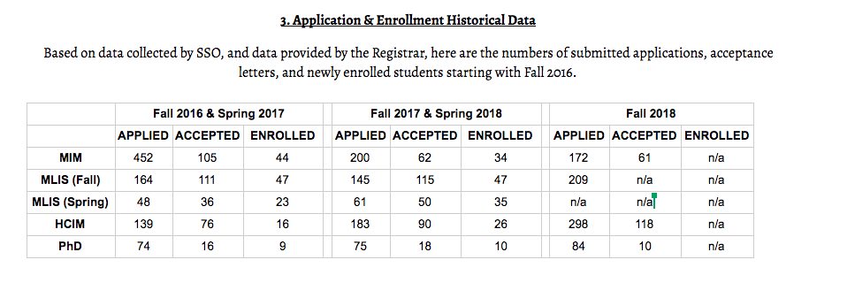

2019 iConference – Mary Kendig (Slides available)
- Talked through slides listing topics and guidelines for partnerships with outside groups
- Asked faculty to send her and/or Mega info on potential outside sponsors

Announcements.
- Jeff – College commencement is Monday May 21; please complete attendance evite he sent
- Dave B – We have a new hire to help with the VCL. He’s in Hornbake Room 0215B; his hours are MWF 9 am – 1 pm
- Brian – Thanked staff for good work. Reminded us there are many staff vacancies. If something falls through the cracks contact him to check on status and how we can help to move the matter along
- Ricky – Nominations committee will choose a chair person soon
- Ricky – Asked if Assembly could revert to its 10 am starting time. After discussion Assembly made decision to ask folks who oversee teaching schedule for info on when people teach and to use that data to determine the best time for Assembly to foster the largest attendance possible. Will revisit next meeting

Meeting Adjourned at 10:45 am.

