Selected University of Maryland Information Technology Resources

Table of Contents:
- Collaboration Services
- Colocation Services
- Data Storage and Backup Services
- High Performance Computing
- Network Capabilities

Collaboration Services
Faculty and staff of the University of Maryland collaborate with each other, as well as peers all over the world, through a diverse set of unified communication and collaboration services. Along with the standard VOIP telephony, web conferencing is provided by an Adobe Connect system capable of supporting up to 1,000 concurrent users. An on premise audio conference bridge provides dial-in capabilities for hosted conference calls to complement the on premise video conferencing system. Additional video capabilities include both desktop and room based systems utilizing standard based video (H.323 and SIP). A common unified communications client integrates all of these services, along with federated instant messaging and presence, into a single view that can be used on any device, at any time, from anywhere.

Colocation Services
Centrally managed, reliable and secure data center facilities are available for IT hardware colocation use by researchers. These facilities are monitored 24X7 and provide researchers with 24X7 physical and remote access to their systems.

Data Storage and Backup Services
Enterprise storage and backup services are available to the campus research community. The Network Attached Storage (NAS) and Storage Area Network (SAN) solutions are designed for redundancy and housed in secure data centers. Backups are stored off site to allow for recovery in the event of a disaster. The NAS service uses EMC Isilon storage arrays. EMC Isilon is a leading provider of highly redundant and ultra-scalable data storage. Through a comprehensive support arrangement with EMC, data storage through NFS, CIFS (SMB) and iSCSI storage protocols is available. Storage utilization is managed by quotas which can be adjusted within a day. Snapshots, replication, and backups for the data stored through the Networked Storage Service address various levels of data protection requirements. Opting for the SAN solution, researchers can choose from different tiers of storage with varying performance and capacity characteristics to meet their needs. All data on these disk storage arrays are backed up.
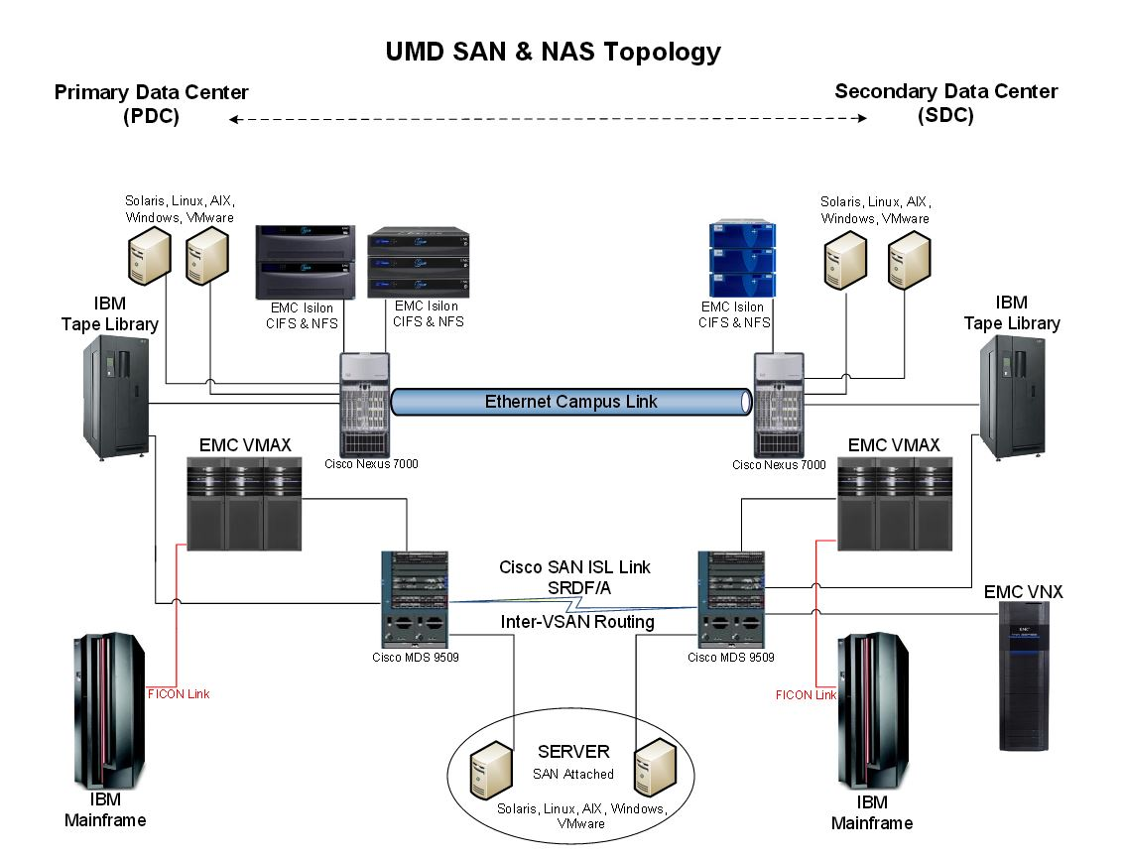

Data protection service is hosted by IBM's Tivoli Storage Manager (TSM) and is available for many operating platforms, including Linux, Solaris, Windows, Netware, and OS X. Protected data can be backed up nightly or done as a one-time "archive." An additional copy of the data is stored in an alternate location.

High Performance Computing
There are three High Performance Computing Clusters available to the research community:

- Deepthought2 – The flagship high performance computing resource for the University of Maryland, Deepthought2 is ideal for large scale parallel processing. The cluster is factory rated at 300 Teraflops. Operational since May 2014, Deepthought2 consists of over 450 nodes, 9200 compute cores, with dual socket Ivy Bridge 2.8 GHz processors, 40 of which have dual Nvidia K20m GPUs. Most nodes have 128 GB of RAM, with some having 1 TB of RAM. All nodes have FDR infiniband (56 Gbps) interconnects, and there is 1 PB of fast Lustre storage.
- Deepthought - A Dell/EMC/UMD partnership provided Deepthought, the original eight node cluster and more than 1TB of storage, establishing a prototype central UMD HPC facility. In the following years, several campus groups along with additional donations from Dell and investments by DIT have contributed significant resources to update the cluster to its present form. The cluster consists of 376 nodes, with 3122 compute cores. This provides a theoretical maximum compute capacity of 35 Teraflops. Approximately one third of the cluster is interconnected with a high-speed Infiniband network, with the remaining two-thirds connected via Gigabit ethernet. Node memory varies from 1GB per core on the oldest nodes up to 4GB per core on the newest. Storage on Deepthought consists of 100 TB of high-bandwidth Lustre storage. Deepthought is available for production use by campus researchers and is now used primarily for small parallel processing, high speed serial processing and application testing.
- Bluecrab - This cluster, housed at the Maryland Advanced Research Computing Center, is jointly managed by the University of Maryland and Johns Hopkins University. It has 746 compute nodes with 19,104 compute cores. The combined theoretical performance of Bluecrab is over 900 Teraflops. It also features two types of storage: 2 PB Lustre (Terascala) and 15 PB ZFS/Linux. The standard compute nodes contain 2 Intel Xeon E5-2680v3 (Haswell) processors, with 12 cores and 128 GB DDR4, 2.5 GHz (Marked TDP frequency) or 2.1GHz AVX base frequency. Each node has a theoretical speed of 960 GFlop/s. The large memory nodes are Dell PowerEdge R920 servers with quad Intel “Ivy Bridge” Xeon E7-8857v2, (3.0GHz, 12 core, 30MB, 130W). Each node has 1024 GB RAM. The GPU nodes are Dell PowerEdge R730 servers with dual Intel Haswell Xeon E5-2680v3 (12 core, 2.5 GHz, 120W), 128 GB of 2133 MHz DDR4 RAM. (AVX frequency: 2.1GHz) and two Nvidia K80s per node. The FDR-14 Infiniband topology is 2:1 with 56 Gbps bandwidth. The Lustre file system provides an aggregate bandwidth of 25 Gbps (read) and 20 Gbps (write).

Network Capabilities
Highlights:
- Converged data, voice and video network
- Over 5,500 wireless access points
- Over 280 buildings
- 11 million feet of single mode fiber
- Network among the nation’s first to be built on industry-standard 100G technologies
- 24x7 monitoring of all network equipment, connections and services
University of Maryland provides cutting-edge networking capabilities to its researchers, students, and collaborators. The network provides a converged data, voice and video network to over 280 buildings on the 1,250 acre campus. All of the buildings are connected to fiber rings with over 11 million feet of single mode fiber. The network is a three-tier model with a core, distribution and access layers. The core is a Layer 3 meshed architecture with two routers and multiple 10Gbps connections to various network segments. The network is connected to multiple service providers at the border, including:
- MAX/Internet2 at 2 x 10Gbps
- Commodity ISP at 2 x 10Gbps
- MDREN at 1Gbps

The end user distribution layers utilize virtual switching service, which allows for geographic redundancy and virtual routing forwarding. This enables segregation of traffic using a two level distribution layer. Buildings are connected by either 1Gbps or 10Gbps dual active/standby uplinks (1Gbps or 10Gbps) or portchannels (2Gbps or 20Gbps) to redundant distribution routers. Buildings that contain high end research have the following services delivered:
- Diverse single mode outside plant to geographically redundant hubs;
- Diverse 20Gbps portchannel uplinks to geographically redundant routers;
- Redundant supervisors, uplinks and power supplies in building distribution switches;
- Hybrid Cat6e, Single Mode and Multi-mode horizontal and vertical cabling;
- UPS and environmental controls for network closets;
- 1Gbps to the desktop;
- Power over Ethernet;
- VOIP telephony and e911 services;
- Full building wireless coverage.
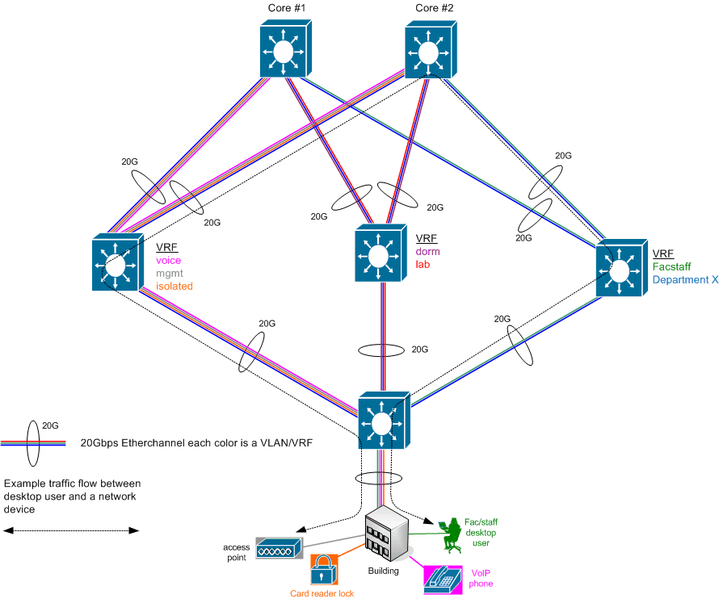

Wireless services are currently provided in every building on campus, and soon will be available in all outdoor spaces on campus. The wireless network is composed of over 5,500 access points supporting 802.11n. Newer installations are receiving 802.11ac access points and a refresh of the wireless network is planned over the next couple of years. The wireless network contains campus SSIDs as well as Eduroam for visiting scholars and researchers.
The data centers on campus supporting research have multiple 10Gbps connections directly to the core via the latest high performance, low latency network architecture and security services. The Division of Information Technology Network Operations Center provides 24x7 monitoring of all network equipment, connections and services, as well as quick diagnosis and resolution of issues that arise.
The Mid-Atlantic Crossroads (MAX), a Gigabit Point of Presence organization (or GigaPoP) led by the University of Maryland has recently deployed its 100G fiber optic network. The network is among the nation’s first to be built on industry-standard 100G technologies. This milestone follows a successful test period by MAX, and the upgraded network meets the large scale data flow requirements of 44 universities, federal agencies, government laboratories, and non-profit institutions in Maryland, Virginia, and the District of Columbia. By implementing this highly-developed network, MAX enables its member organizations to study and advance understanding in critical areas that include climate modeling, genetics, and visualization. The valuable research conducted is dependent upon MAX’s high-performance data transfer capabilities and advanced network services.

