iSchool Reimbursement and Travel Processes

Travel & Reimbursement
Two forms are needed for reimbursement when traveling—the Travel Approval Form (TAR) and the Travel Reimbursement Form (TES). The TAR needs to be filled out in advance, and the TES following your travel. Please note that there are many requirements and regulations involved in the reimbursement of travel expenses, so if you have questions after reading this section, it is a good idea to clarify the procedures in advance of scheduling your trip.
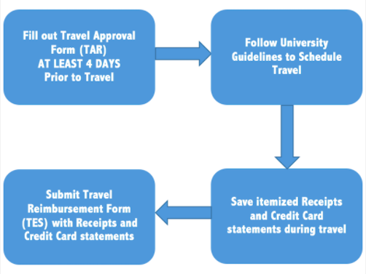

Where to find forms?
- Printed versions are available at the Administrative Office

About Travel Approval Forms (TAR)
Travel approval forms should be submitted to the Administrative Office at least 4 days before the start of a trip. This allows time to have the information processed through the University system by the time the trip starts. For more information, check the university travel policy.

Key things to remember when completing this form
- Note any charges that are on a University credit card
- Cost amounts provided on this form are best estimates
- Make sure that the dates, travel destination and purpose are correct
- Remember to provide the name of a grant or account number to which the trip will be charged

Travel Reimbursement Forms (TES – Travel Expense Statements)
Travel reimbursement forms should be submitted no later than 30 days after the completion of travel. A reimbursement form is not the same as a travel approval form and must be submitted to the Administrative office in order to request a reimbursement.

Key things to remember when completing this form
- Please ONLY include amounts for which you are seeking reimbursement.
- Make sure that the dates, travel destination (include airport codes) and purpose are correct.
- Provide the name of a grant or account number to which the trip will be charged.
- Include all receipts required (Receipts must show form of payment – e.i. last 4 digits of the credit card).
  - Hotel receipts/invoices – must provide final invoice provided at check-out.
  - For taxis and parking – original receipts are required.
  - Baggage fees – if paid at the airport original receipt/verification provided by airline must be submitted
  - Meals with receipts (instead of per diem) – must provide original itemized receipts. Meal receipts are not required if you are using per diem rates.
- You must include copies of credit card(s) or credit card statement(s) [non-relevant charges and info should be blacked out]. This is standard University policy. Reimbursements will not be approved without these copies.
- If requesting car mileage reimbursement please provide a Mapquest or Google Maps print out showing the mileage from point to point.
- Before sending the TES paperwork to Accounts Payable for processing, you must sign the final form.
- For international trips please include print out of the State Department per diem rate used.

Additional notes on international travel
- Use the State Department per diem rates to determine your per diem rate.
- To comply with the Fly America Act, you must use one of the following airlines.
  - AirTran
  - American
  - Delta
  - Southwest
  - United
  - US Airways
  - GSA provides further information and additional airlines.
- For currency conversion, the OANDA conversion service is recommended.

Additional notes on local travel
You do not need to submit a TAR for in-state travel (including travel to Washington, DC) that does not require an overnight stay. Please submit your receipts directly to the Contracts and Grants Coordinator.

